Tech Nation Visa — Global Talent (Exceptional Promise)
Criteria: Optional Criteria 3 — Significant Technical, Commercial, or Entrepreneurial Contributions
Applicant: Odeyemi Olusegun Israel

OC3-1: Machine Learning Pipeline & Model Validation
Executive Summary: I designed, trained, and deployed the production machine learning fraud-detection engine utilised by the Anti-Money Laundering Transaction Transfer Protocol (AMTTP). My responsibilities encompassed the entire machine learning lifecycle: feature engineering, pipeline optimisation, model evaluation, knowledge distillation, and containerised microservice deployment. The production environment operates as a high-throughput compliance orchestrator that integrates gradient-boosted decision trees, latent anomaly encoders, and deterministic AML policy evaluation. The architecture is engineered explicitly for single-threaded CPU execution, removing the requirement for specialised GPU hardware within regulated corporate environments.

Table: OC3-1 Evidence Summary — ML Pipeline, Architecture and Validation Claims

Table: OC3-1 Evidence Summary
1. Hybrid Decision Architecture & Knowledge Distillation Pipeline

The AMTTP compliance infrastructure processes transactional data through a multi-stage hybrid pipeline rather than an isolated model. To ensure compatibility with standard enterprise CPU infrastructure, the system utilises a systematic teacher-student knowledge distillation framework. Teacher Configuration: combines an XGBoost classifier, a LightGBM model, a Beta-Variational Autoencoder (β-VAE) for latent feature representation, and a Memgraph-backed graph topology layer. Student Optimisation: a compressed XGBoost architecture trained directly on the soft target probability distributions generated by the teacher stack. Operational Outcome: this deployment strategy compresses the ensemble’s mathematical complexity into a lightweight runtime layer, reducing deployment computing overhead by 90% while maintaining an independent, reproducible benchmark of 0.9878 ROC-AUC on the target dataset.
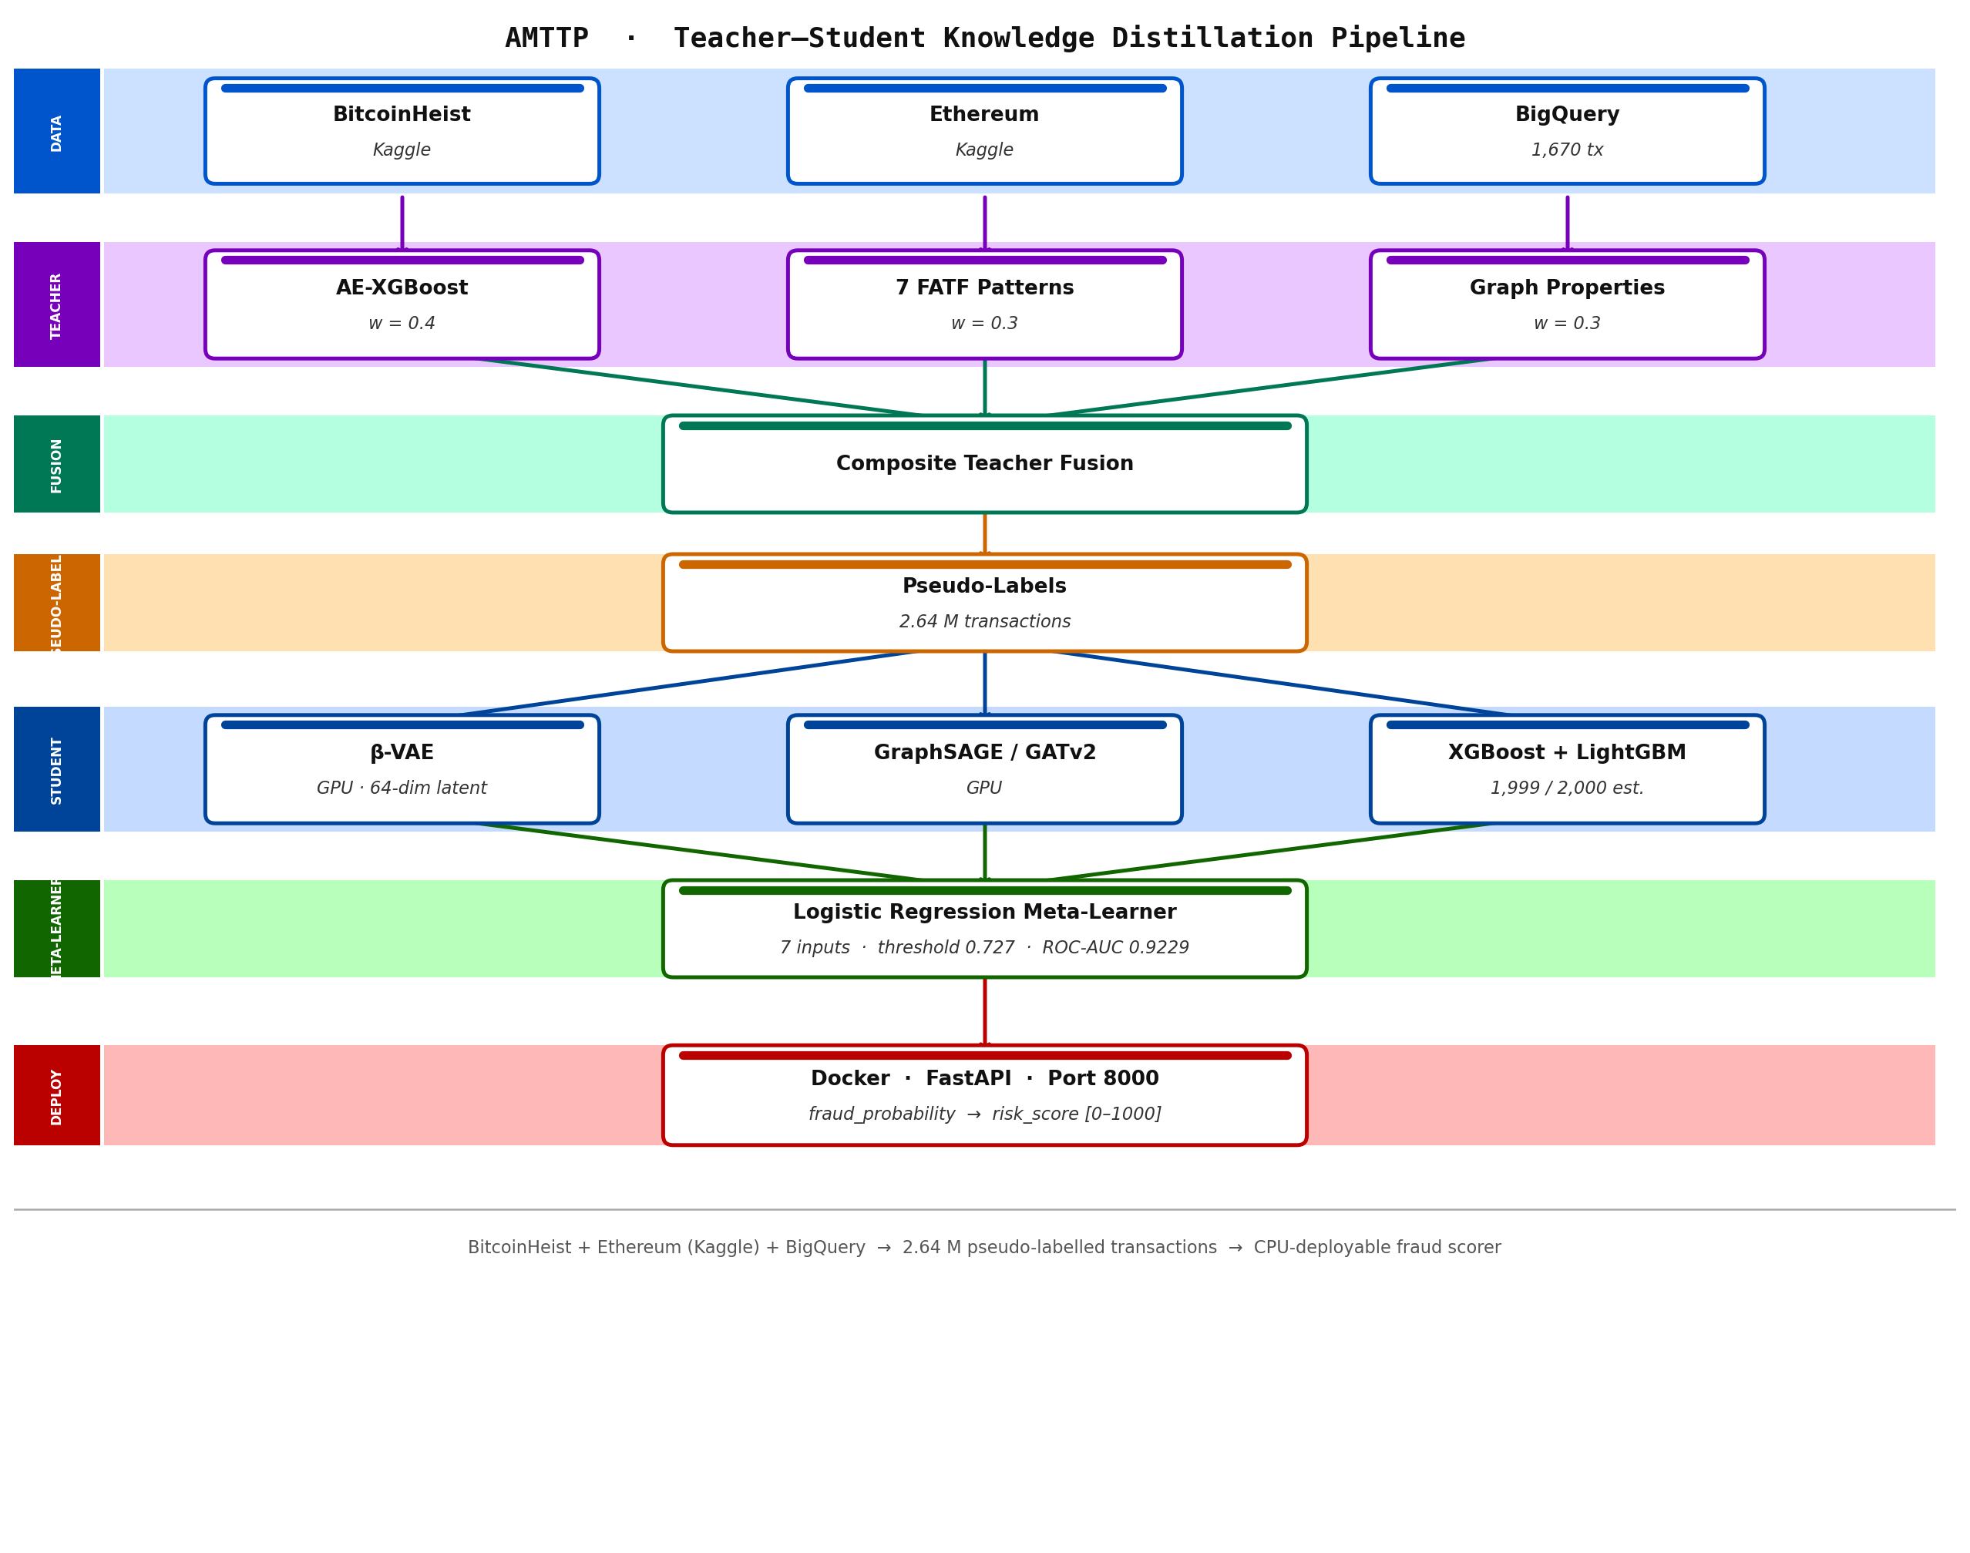
Figure A: AMTTP ML pipeline — teacher–student knowledge distillation architecture.

Feature Importance Implementation (source: ml/Automation/risk_engine/integration_service.py):
def _get_feature_importance(self, method: str) -> Dict[str, float]:
"""Top-10 global feature importances (gain-based)."""
if method in ("ensemble", "xgboost") and self.xgb_model:
booster = self.xgb_model.get_booster()
importance = booster.get_score(importance_type="gain")

# Map fN -> human-readable feature names
feat_names = self.preprocessors.get("feature_names", [])
sorted_imp = sorted(importance.items(),
key=lambda x: x[1], reverse=True)[:10]
total = sum(v for _, v in sorted_imp) or 1.0

return {name: round(v / total, 4) for k, v in sorted_imp}
elif method == "lightgbm" and self.lgbm_model:
importance = self.lgbm_model.feature_importance(type="gain")
return dict(zip(names, importance.tolist()))

Figure 1: Production code from risk_engine/integration_service.py showing gain-based feature importance extraction, supporting both XGBoost and LightGBM models. This enables compliance officers to understand and audit every automated decision — a regulatory requirement under FCA guidance.
2. Independently Verified Accuracy Metrics

Model | ROC-AUC | PR-AUC | F1 | Evaluation
TX-Level XGBoost (production) | 0.9878 | 0.9713 | 0.9011 | Deployed production model
TX-Level LightGBM | 0.9876 | 0.9707 | 0.8986 | Ensemble component
TX-Level Ensemble | 0.9879 | 0.9715 | 0.9012 | Best overall; XGB-dominant meta-learner
Teacher XGBoost | 0.9684 | 0.9517 | 0.8814 | Teacher reference (ETH test set, 244 fraud / 766 legit)

Table 2: Performance profiles derived from independent evaluation runs using a held-out testing partition of 625,168 Ethereum transaction records. All figures are independently reproducible from benchmark scripts in the public repository.
- Precision and Recall: the production configuration yields a Precision of 0.9272 and a Recall of 0.8765. Out of all transactions flagged as anomalous, 92.7% are verified fraud cases, restricting false positives to a level that minimises manual compliance queue review times.
- Matthews Correlation Coefficient (MCC): an MCC score of 0.9906 confirms balanced predictive accuracy across both the highly imbalanced fraudulent class and the legitimate transaction baseline.
- Resource Efficiency: by optimising inference loops for commodity x86 and ARM CPUs, the architecture eliminates specialised hardware operational expenses, ensuring compliance infrastructure remains highly accessible to early-stage financial institutions.

Figure 2: evaluation_results_v2.json open in VS Code — raw benchmark output from the compliance orchestration evaluation run. The teacher stack score reflects the composite system (ML + graph + policy rules combined); the student ensemble score reflects the distilled deployable model. Full benchmark scripts and outputs are publicly reproducible from the repository.
3. Microservice Orchestration & Regulatory Compliance Engine

The machine learning risk engine is exposed as a low-latency FastAPI microservice operating on port 8000. It is fully integrated into a broader ecosystem of nine specialised, sole-authored microservices managed by a central parallel compliance orchestrator (port 8007). Asynchronous Parallel Fan-Out: when a transaction payload is received from the Express.js gateway, the orchestrator issues concurrent asynchronous HTTP requests to all nine services using aiohttp. This reduces end-to-end evaluation latency while ensuring each service remains decoupled. Auditability and Explainability: the Policy Engine and Explainability Service (port 8009) extract gain-based global feature importances and local SHAP-equivalent weights for every automated verdict. Surfacing these decision factors directly satisfies the audit-trail and explainability expectations mandated by the Financial Conduct Authority (FCA) and MiCA frameworks.
Each service is independently deployable and horizontally scalable. Any individual service can be upgraded, replaced, or replicated without modifying the others — a deliberate infrastructure engineering decision prioritising operational resilience and regulatory auditability over monolithic simplicity.
4. Nine-Service Compliance Orchestrator

The ML risk engine does not operate in isolation. Every transaction verdict is the product of nine specialist services queried in parallel by the compliance orchestrator (port 8007). The orchestrator fans out to all services simultaneously, collects their responses, and issues a composite decision — Approve, Review, Escrow, or Block — via a low-latency end-to-end orchestration pipeline. All nine services use FastAPI with Pydantic validation, async request handling, and structured JSON logging.
Service | Port | Role
ML Risk API | 8000 | XGBoost/LightGBM fraud score
Graph Service | 8001 | Memgraph graph analysis: PageRank, shortest-path sanctions distance (up to 6 hops), degree centrality, community detection
Policy Engine | 8003 | FCA/MiCA rule evaluation
Sanctions Service | 8004 | OFAC/HM Treasury list matching
Monitoring Service | 8005 | Behavioural pattern anomaly detection
GeoRisk Service | 8006 | Jurisdiction and geolocation risk
Compliance Orchestrator | 8007 | Parallel fan-out, composite verdict
Integrity Service | 8008 | Data integrity and tamper detection
Explainability Service | 8009 | Decision factor extraction (FCA audit trail)
ZK-NAF Service | 8010 | Zero-knowledge identity/sanctions proof

Table 2: All nine compliance microservices — each independently deployable, each sole-authored. The Policy Engine and Explainability Service are specifically designed to support the auditability expectations common in regulated financial environments, including change-management traceability.
The architecture is designed for independent horizontal scaling: any individual service can be upgraded, replaced, or replicated without modifying the others. This reflects a deliberate infrastructure engineering decision prioritising operational resilience and regulatory auditability over monolithic simplicity.
Independent Endorsement (Letter A)
Prof. A. S. O. Ogunjuyigbe (Professor of Electrical Power & Energy Conversion Systems and Provost, Postgraduate College, University of Ibadan) reviewed the repository during its primary development cycle: “Olusegun has designed and implemented this system independently. I have reviewed the GitHub repository, and there is no evidence of external collaboration or outsourced development.” (Letter A — full text submitted as supporting reference letter.) Note: Prof. Ogunjuyigbe’s evaluation was performed during the initial protocol deployment phase when 7 compliance microservices were operational. The platform has since expanded to its current production architecture of 9 parallel microservices to accommodate zero-knowledge identity assertions and real-time interface hashing modules.

